# **Supplement**

## ***Details on methods***

### ***Identification and typification of interactions***

The collection of news articles was in collaboration with Ypa (2025), who explored a wider range of interactions between humans and pumas in Argentina based on online news via Google News. Each hyperlink corresponding to an online article published between 2017 and 2022 was systematically cataloged in a table. This process involved the manual assignment of attributes such as the publication date and provincial origin, while the specific location was located with Google Earth Pro (Google Inc., 2022). To ensure data accuracy, diligent efforts were made to eliminate duplicates, resulting in a refined dataset, reduced from an initial count of more than 800 online news articles to a conclusive total of 291, devoid of duplications. These articles were then manually categorized into 12 different classes, whereby each article can fall into several categories. These categories were conceived based on potential interactions between humans and pumas, including e.g. “sightings”, “rescue efforts”, “road accidents”, “domestication” (Ypa, 2025). For this study, we chose the categories “depredation on livestock”, “retaliatory hunting”, and “trophy or sport hunting”. For depredation conflicts, including retaliatory hunting, news articles had to explicitly mention livestock depredation or persecution related to a depredation event, whereas for hunting, only hunting puma was reported. After removing articles without an exact location (e.g. because they reported on the entire province), the final news dataset contained 43 articles that were classified "depredation conflict", and 29 articles addressed the topic of “hunting”.

The hunting areas for this study were derived from maps provided by Gallo et al. (2020, 2022), as they utilized the same data on hunted pumas per municipality in Chubut from Llanos et al. (2014), whose database is not publicly available.

### ***Variable calculation process and data sources***

For roads, we calculated the cumulative length of paved and unpaved roads (in km). For protected areas, we determined the closest distance from each interaction area border to protected areas (borders) at national and sub-national level. Livestock variables were derived by calculating the total number of heads per interaction area for both cattle and small livestock, including goats and sheep. Population density was also calculated as the total number of heads per interaction area. Information on land cover within the interaction area was extracted from the MapBiomas Argentina (MapBiomas Argentina - Colección 1). Finally, we calculated the number of settlements per interaction area using data from the IGN (IGN, 2021). Figure S1 presents an overview of the spatial distribution of each variable.

*Total length of roads (paved/ unpaved)*

Geospatial road data for Argentina is available from the IGN (IGN, 2021). Various datasets are accessible at national, provincial, and tertiary levels containing relevant information on road surface characteristics, distinguishing between paved and unpaved surfaces. Since the official road designation is not relevant for the conflict analysis, a distinction was made between paved and unpaved road sections for each data set and compiled into two coherent data sets independent of the level and based only on the road surface (paved or unpaved). The cumulative length of the roads (in km) within the designated buffers was then calculated using the vector analysis tool *sum line length* in QGIS.

*Distance to protected areas (PA)*

Data about PA’s were taken from the IGN (IGN, 2021). For Argentina the database was more detailed in comparison to the data from the World Database on Protected Areas (WDPA) (UNEP-WCMC & IUCN, 2023). It includes national as well as subnational (at provincial, municipal or private scale) PA’s. To calculate the distance to the closest PA, we created a dissolved dataset from the PA’s to mitigate potential overlaps. The tool *shortest line between features* calculated the cartesian distance to the nearest polygon from the conflict buffer border. The distances were revised using the measure tool in QGIS. In cases where conflict areas overlapped with PA boundaries, resulting in a distance calculation of 0, a distance of 0.001 km was assigned to avoid inconsistencies in the model.

*Livestock density*

The 2015 livestock database contains information about the number of different livestock species per km2 with a resolution of 10 km (Gilbert et al., 2022a, 2022b, 2022c). It is a worldwide database, which we first clipped to the extent of Argentina. We created three separate variables to include different types of livestock production that exist in Argentina and possible dietary preferences of pumas: one for “small livestock” including goats and sheep, and one for “cattle”, and a third that includes all three species (“livestock”). We used the *zonal statistics* tool to calculate the total (summarized) sum of heads per km2 per variable in each conflict area.

*Population density*

The data about population density was downloaded from the GHSL (Schiavina et al., 2023). Again, the *zonal statistics* tool was used to calculate the sum of population density for each conflict area. Here, we also chose the sum instead of the mean value to be consistent with the other variables.

*Land Cover*

MapBiomas Argentina was launched in May 2024 and provides land cover data (MapBiomas Argentina - Colección 1). We calculated the total area of the land cover/use classes defined by MapBiomas. For example, the class “agriculture and livestock area” (which we used as “agriculture”) includes pasture, agriculture, forest plantation, bush cultivation, agricultural mosaic. To determine the distribution of land cover types within each interaction area, we used the *zonal histogram* tool. Since the tool provides pixel counts, we converted the results to km2. We checked the results by examining very homogeneous conflict areas and comparing them to the maximum possible area of 1256 km².

*Settlement area*

The ESA WorldCover database provides global land cover data with a resolution of 10 m from the year 2021 (Zanaga et al., 2022). They defined 11 classes based on the Land Cover Classification System (LCCS). This database offers a user-friendly process for downloading the data and provides relatively up-to-date data. Since we decided to use the more local land cover data product, we only calculated the settlement area based on this database. We used the *zonal histogram* tool and converted the results to km2.

*Number of settlements*

To determine the number of settlements in each conflict area, we used the settlement data from IGN. It includes 3375 settlements in Argentina described as “Approximate urban area that includes the contiguous area of built-up development, whose limits are recognizable” (IGN, 2021). It is not limited to a minimum area size and does not consider the population sum or density of a settlement. Few settlements within one conflict buffer point at larger settlements, whereas a higher number of settlements per conflict buffer is an indication for smaller and more rural settlements. To calculate the number of settlements per conflict buffer, we first created a layer with settlement centroids using the "Centroid" vector tool and then calculated the number of points within each conflict area using the "Count points in polygon" tool.

### ***Creating pseudo-absences***

Buffers intersecting presence (interaction) areas were excluded to emulate real absences. Buffers extending significantly beyond Chilean or neighboring borders were also removed to avoid regional misrepresentation, given the limitations of certain spatial datasets, such as roads, to Argentina.

### ***Model selection***

To select the best respective model, we used the Akaike Information Criterion ΔAIC < 2 criteria, which is a relative measure of model parsimony and often used for model selection (Arnold, 2010), using the *AIC()* function in the R package *stats.* and retained covariates with 90% confidence intervals that exclude zero as useful for inference (Arnold, 2010). We applied the likelihood ratio test for comparing the goodness-of-fit of nested models with the *lrtest* function of the *lmtest* package in R (Zeileis, 2022) to see if the additional parameters in the fitted model significantly improve the fit to the data compared to the null model. A p-value below the significance levels shows an improvement by including the predictor variables, compared to the null model.

After that, we calculated the Variance Inflation Factor (VIF) with the *vif* function of the *car* package in R (Fox et al., 2023) to reassure that there is no multicollinearity among the predictor variables. Here, a value of 0 implies no correlation, values between 1 and <5 moderate but not severe correlation, and values >5 high correlation (Sheather, 2009).

The coefficients of the variables, their p-values and confidence intervals are crucial to explore variable importance. The confidence interval was set to 90%. The general descriptive power of the model was evaluated with the commonly used McFadden pseudo R2 measure. This metric measures the proportion of variance explained (McFadden, 1972) and was calculated with the *pR2* function of the *pscl* package in R (Jackman, 2024).

Finally, the Area Under the Curve (AUC) value is defined as the area under the Receiver Operating Characteristic (ROC) curve, and was used to check the model’s discriminatory power (Fielding & Bell, 1997), meaning the ability to distinguish between (here: binary) classes. An AUC of 1 means perfect classifier, whereas an AUC of 0.5 means rather random classification. To test for the AUC using the *pROC* package in R (Robin et al., 2023), we randomly divided the data into training and testing data with a 30/70 ratio. We used the Monte-Carlo cross-validation technique with 1000 iterations to stabilize the AUC estimate and mitigate the variability due to small sample sizes. AUC values close to 1 imply a good fit in terms of discrimination (>0.9), whereas values between 0.7 and 0.9 stand for moderate discrimination and a value of 0.5 represents random chance (Benito & Peñas, 2007; Kihn et al., 2021; Rostro-García et al., 2016).

# **Supplementary Figures**

## ***Figure S1***

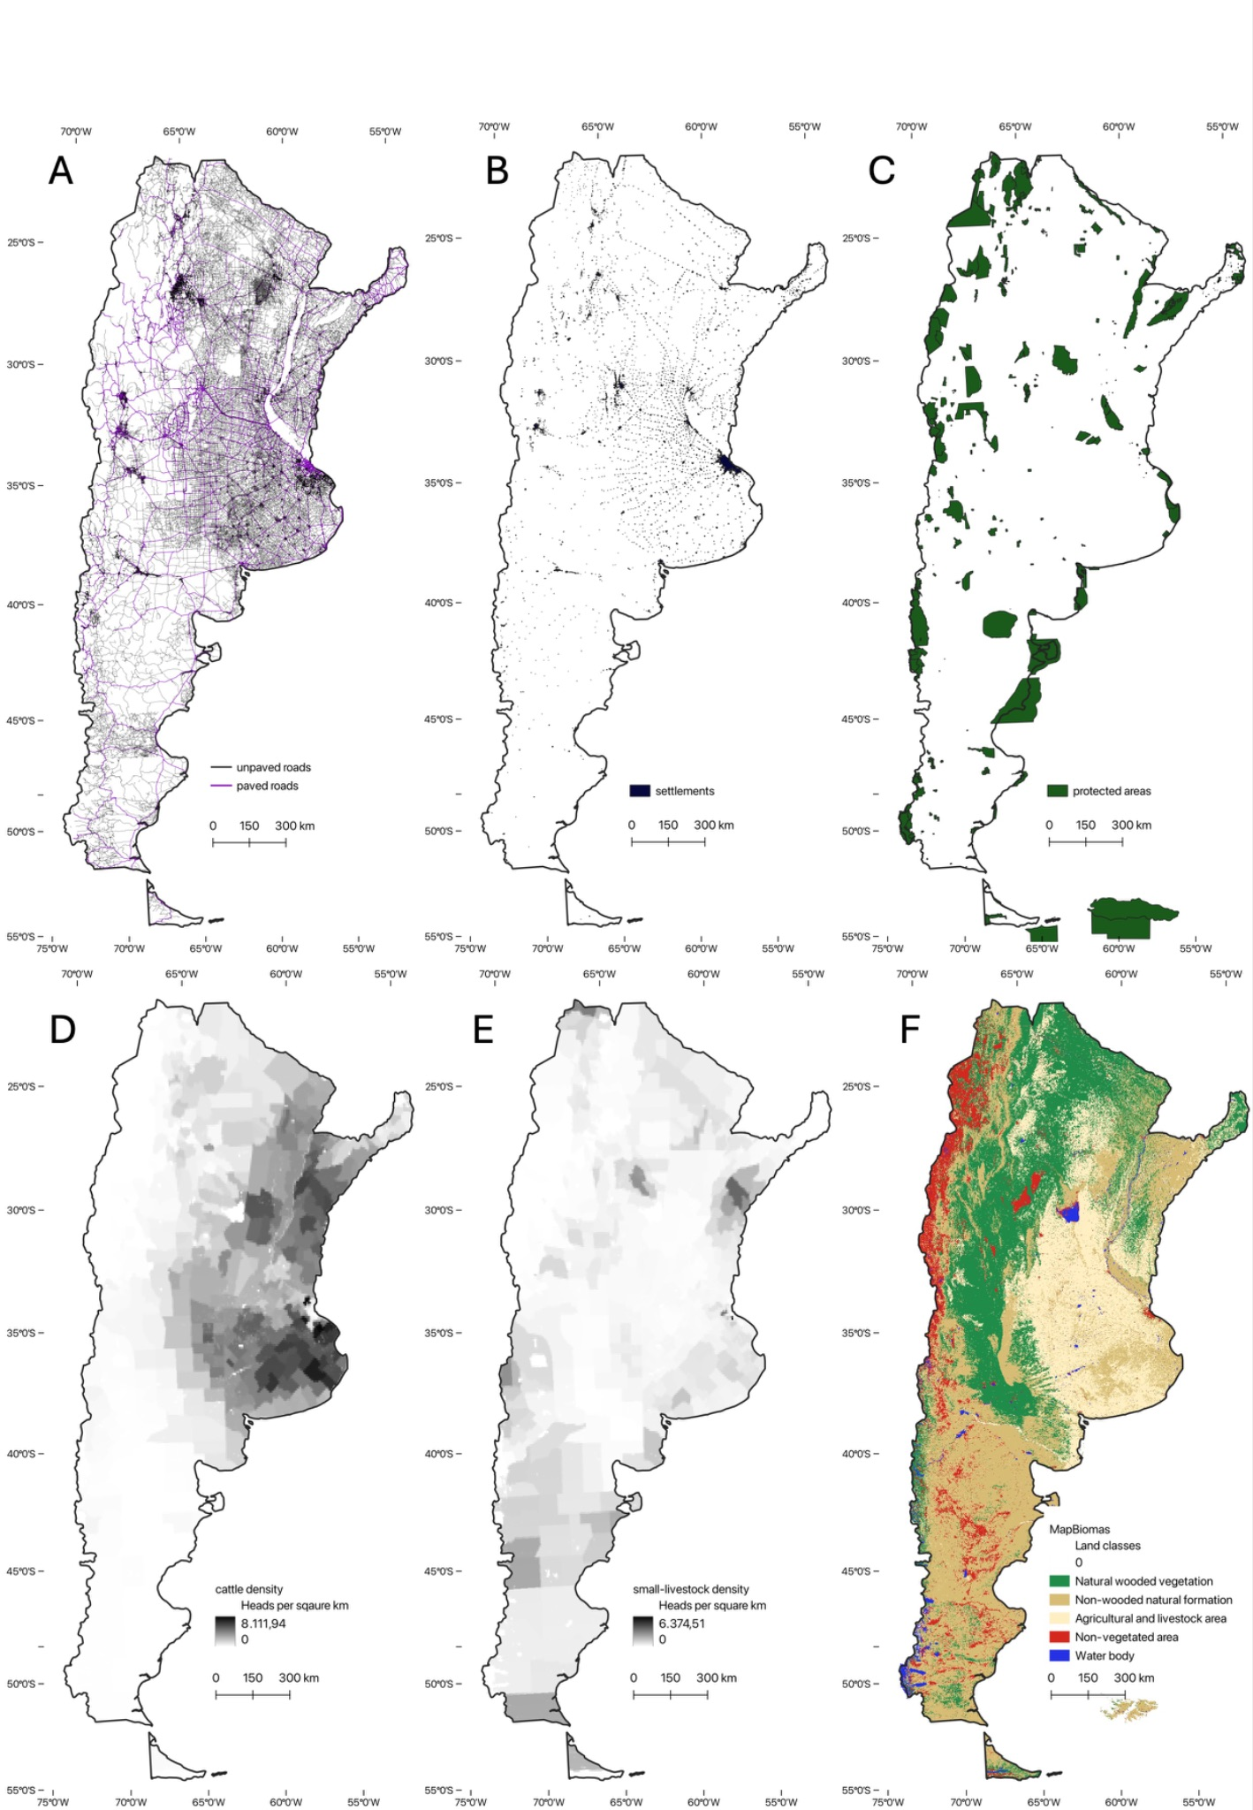

Figure S1:Multiplot of selected social or ecological variables of Argentina. **A** shows paved and unpaved roads (IGN, 2021); **B** shows protected areas (IGN, 2021); **C** shows settlements (IGN, 2021); **D** shows small-livestock density & **E** shows cattle density (Gilbert et al., 2022a, 2022b, 2022c); **F** shows land cover (Zanaga et al., 2022).

## 

## **Figure S2**

**A**

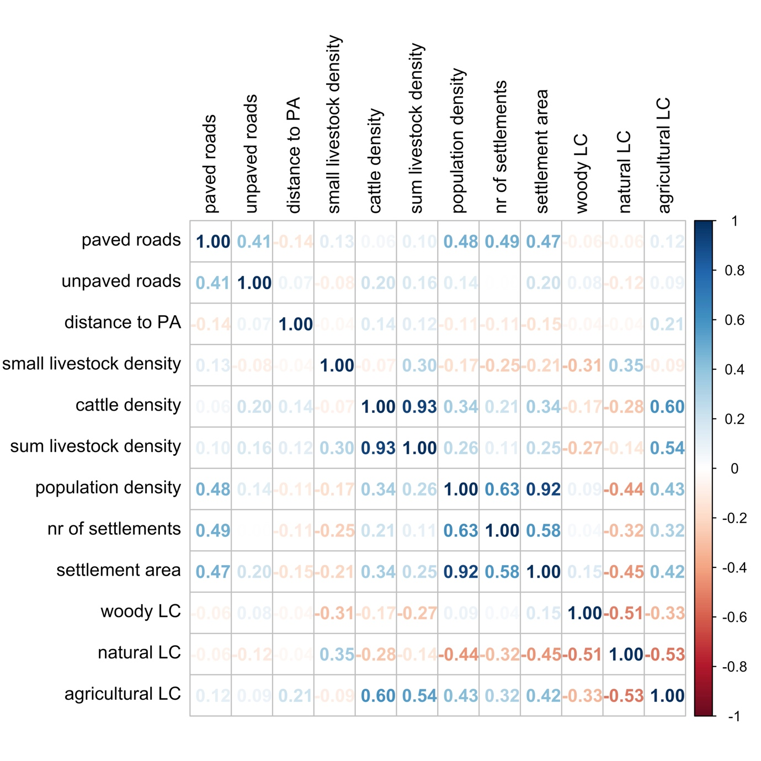

**B**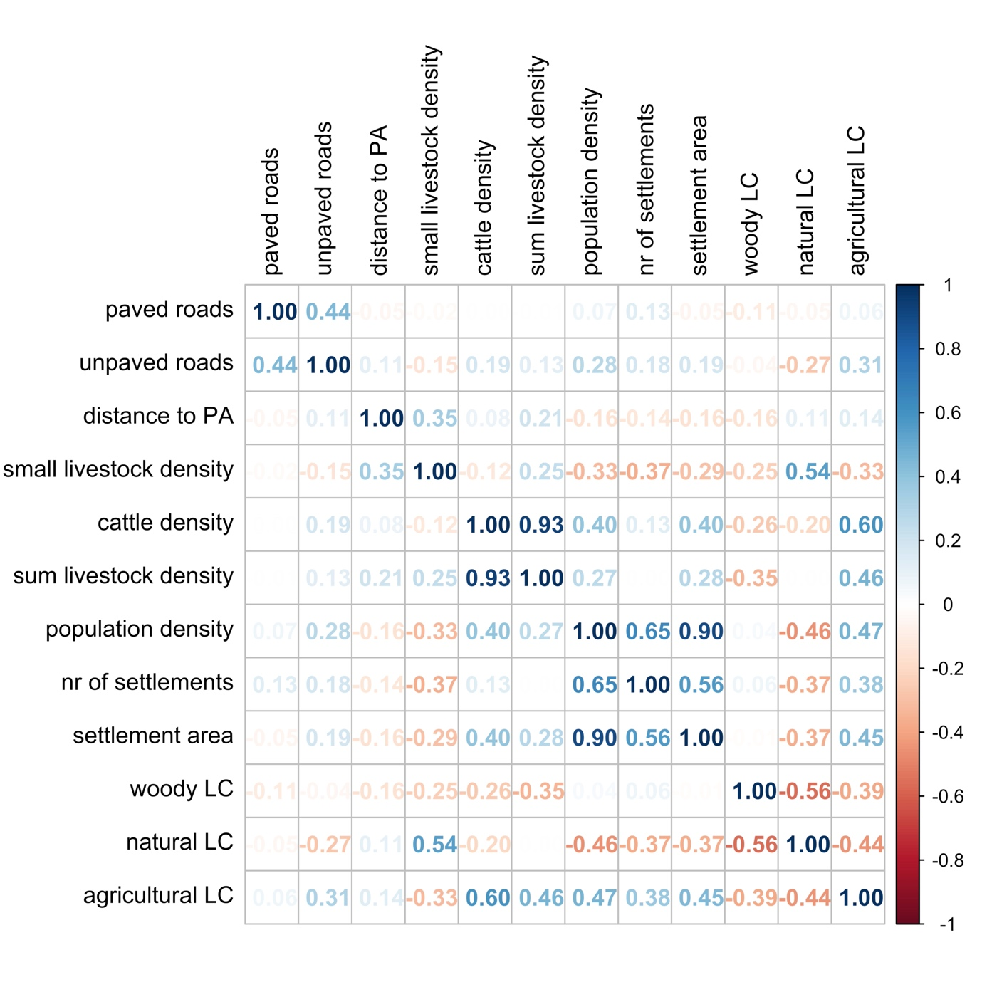

Figure S2: Pearson correlation (r) matrix of social and environmental variables that were considered for modeling human-puma conflicts in Argentina, **A** for depredation interactions, **B** for hunting interactions. Threshold was set to |r|≤0.60. Positive correlations in blue, negative correlations in red.

## **Figure S3**

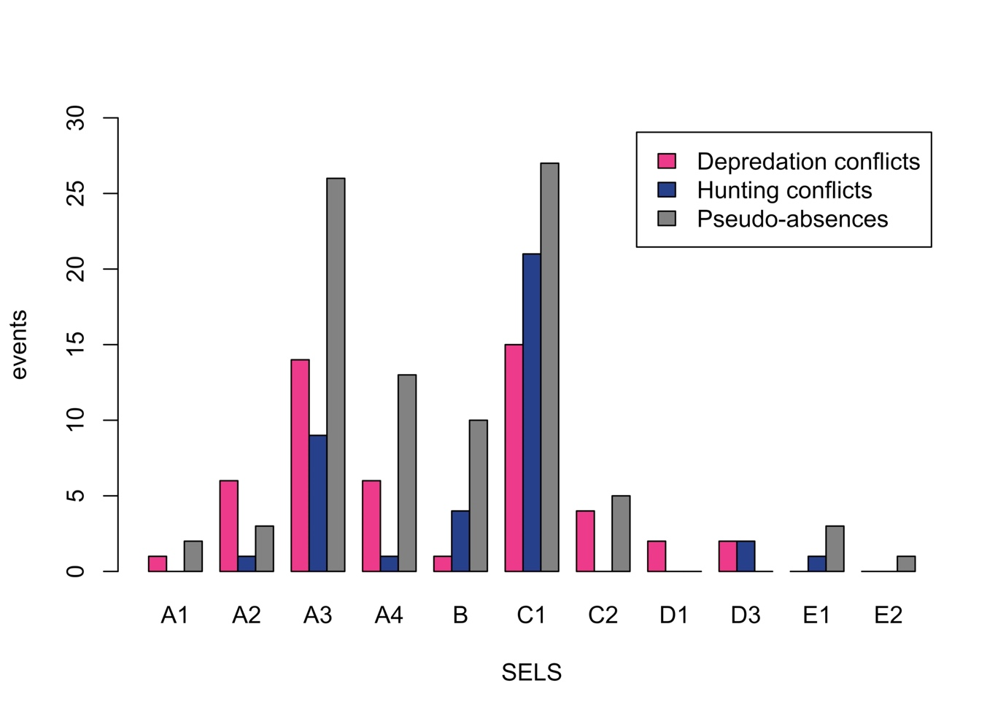

Figure S3: Distribution of depredation conflicts (pink), hunting conflicts (blue), and pseudo-absences (grey) per social-ecological land system (SELS) type in Argentina. For detailed SELS description legend see Figure 1.

## **Figure S4**



Figure S4: Amount of different Social-Ecological Land Systems (SELS) within conflict areas in Argentina. The lighter the point color, the homogeneous the SELS in that area; the darker the point color, the heterogeneous the area. Point border colors indicate data sources (black = news article; white = scientific articles). Map background color represents social-ecological land system (SELS) types (data source: Zarbá et al. (2022)). For detailed SELS description legend see Figure 1.

# 

# **Supplementary Tables**

## **Table S1**

Table S1: Percentage share of SELS type areas in Argentina.

|  |  |
| --- | --- |
| SELS type | Percentage share of area in Argentina |
| A1 | 3.08% |
| A2 | 6.7% |
| A3 | 25.04% |
| A4 | 9.57% |
| B | 7.63% |
| C1 | 36.03% |
| C2 | 3.55% |
| D1 | 0.85% |
| D2 | 1.07% |
| D3 | 1.08% |
| E1 | 3.49% |
| E2 | 0.71% |
| E3 | 1.19% |

## **Table S2**

Table S2: Keywords and search queries used for literature review on 1) depredation interaction, and 2) hunting interaction in Argentina.

|  |  |
| --- | --- |
| **Depredation conflict** – keywords: | "puma", "cougar", "mountain lion", "livestock", "conflict", "predat*", "human wildlife conflict", "human carnivore conflict", "sighting", "attack" |
| Search query: | "Argentin* AND (puma OR cougar OR mountain lion OR carnivore) AND ((conflict* OR predat* OR human-wildlife OR human-carnivore OR sighting* OR attack) OR livestock)” |
| **Hunting conflicts** – keywords: | “hunt*”, “kill*”, “trophy”, “sport”, “people”, “human” |
| Search query: | “Argentin* AND (puma OR cougar OR mountain lion) AND (hunt* OR trophy OR sport OR kill*) AND (human* OR people OR individuals) NOT ("predation" OR "prey")“ |

## 

## **Table S3**

Table S3: Further social and ecological variables selected for analyzing human-puma conflicts in Argentina. It contains the unit description, expected influence on depredation conflicts (depr.) and hunting conflicts (hunt.), and data source.

|  |  |  |  |
| --- | --- | --- | --- |
| **Variable** | **Description** | **Expected influence + Reason** | **Source** |
| Unpaved roads | Total length of roads per conflict area (km) | **Depr.:** +/-  **Hunt.:** + | (IGN, 2021) |
| Protected areas | Distance to nearest PA (km) | **Depr.:** -  **Hunt.:** + | (IGN, 2021) |
| Small livestock | Total sum of heads from goats and sheep per km2 per conflict area | **Depr.:** +  **Hunt.:** + | (Gilbert et al., 2022b, 2022c) |
| Cattle density | Total sum of heads from cattle per km2 per conflict area | **Depr. & Hunt.:** + | (Gilbert et al., 2022a) |
| Number of settlements | Number of settlements within a conflict area | **Depr. & Hunt.:** + | (IGN, 2021) |
| Population density | Number of population density within a conflict area | **Depr.:** +  **Hunt.:** + | GHSL (Schiavina et al., 2023) |
| Agriculture | **definition**  areas per conflict area (km2) | **Depr.:** +  **Hunt.:** + | MapBiomas Argentina |

## **Table S4**

Table S4: List of reviews research articles for literature review on livestock depredation conflicts and trophy hunting conflicts in Argentina between 2017 and 2022.

|  |  |  |  |  |
| --- | --- | --- | --- | --- |
| **Author** | **Year** | **Location in Argentina** | **Conflict type** | **Citation** |
| Cocimano et al. | 2022 | Puna ecoregion | Livestock depredation  +  Retaliatory killing | Cocimano, M. A., Nanni, A. S., & Izquierdo, A. E. (2022). Co-building knowledge on human-puma conflict: A case study in a village of the Argentine Puna ecoregion. *Human Dimensions of Wildlife*, *27*(4), Article 4, <https://doi.org/10.1080/10871209.2021.1954267> |
| Gáspero et al. | 2018 | North-west Patagonia, Río Negro province | Livestock depredation  +  Retaliatory killing | Gaspero, P. G., Easdale, M. H., Pereira, J. A., Fernandez-Arhex, V., & Von Thungen, J. (2018). Human-carnivore interaction in a context of socio-productive crisis: Assessing smallholder strategies for reducing predation in North-west Patagonia, Argentina. *Journal of Arid Environments*, *150*, 92–98. <https://doi.org/10.1016/j.jaridenv.2017.12.005> |
| Guerisoli et al. | 2017 | Southern Buenos Aires Province, Espinal Ecoregion | Livestock depredation  +  Retaliatory killing | Guerisoli, M., Luengos Vidal, E., Franchini, M., Caruso, N., Casanave, E. B., & Lucherini, M. (2017). Characterization of puma–livestock conflicts in rangelands of central Argentina. *Royal Society Open Science*, *4*(12), 170852. <https://doi.org/10.1098/rsos.170852> |
| Guerisoli et al. | 2021 | - | Livestock depredation  +  Retaliatory killing | Guerisoli, M., Luengos Vidal, E., Caruso, N., Giordano, A. J., & Lucherini, M. (2021). Puma-livestock conflicts in the Americas: A review of the evidence. *Mammal Review*, *51*(2), Article 2. <https://doi.org/10.1111/mam.12224> |
| Kihn et al. | 2021 | Northeast of Chaco province, Humid Chaco, rural areas | Livestock depredation  +  Retaliatory killing | Kihn, M. P., Caruso, N., Iaconis, K., Gonzalez, M. J. P., & Soler, L. (2021). Analysis of conflicts with wild carnivores in the Humid Chaco, Argentina. *Animal Biodiversity and Conservation*, *44*(2), Article 2. <https://doi.org/10.32800/abc.2021.44.0251> |
| Llanos et al. | 2020 | Chubut province, central Patagonia | Livestock depredation  +  Retaliatory killing | Llanos, R., Andrade, A., & Travaini, A. (2020). Puma and livestock in central Patagonia (Argentina): From ranchers’ perceptions to predator management. *Human Dimensions of Wildlife*, *25*(1), Article 1. <https://doi.org/10.1080/10871209.2019.1668987> |
| Llanos & Travaini | 2020 | Eastern Chubut province, central Patagonia | Livestock depredation | Llanos, R., & Travaini, A. (2020). Diet of puma (Puma concolor) in sheep ranches of central Patagonia (Argentina). *Journal of Arid Environments*, *177*, 104145. <https://doi.org/10.1016/j.jaridenv.2020.104145> |
| Lucherini et al. | 2018 | Global (mostly Americas), here: Southern Buenos Aires province | Livestock depredation | Lucherini, M., de las Mercedes Guerisoli, M., & Luengos Vidal, E. M. (2018). Surplus killing by pumas Puma concolor: Rumours and facts. *Mammal Review*, *48*(4), Article 4. <https://doi.org/10.1111/mam.12135> |
| Nanni et al. | 2021 | Dry Chaco ecoregion | Livestock depredation  +  Retaliatory killing | Nanni, A. S., Teel, T., & Lucherini, M. (2021). Predation on livestock and its influence on tolerance toward pumas in agroecosystems of the Argentine Dry Chaco. *Human Dimensions of Wildlife*, *26*(5), Article 5. <https://doi.org/10.1080/10871209.2020.1843742> |
| Pereira et al. | 2020 | Central Argentina, Monte ecoregion | Livestock depredation  +  Retaliatory killing | Pereira, J. A., Thompson, J., Di Bitetti, M. S., Fracassi, N. G., Paviolo, A., Fameli, A. F., & Novaro, A. J. (2020). A small protected area facilitates persistence of a large carnivore in a ranching landscape. *Journal for Nature Conservation*, *56*, 125846. <https://doi.org/10.1016/j.jnc.2020.125846> |
| Gallo et al. | 2020 | Provinces  Río Negro, Chubut, Buenos Aires | Trophy hunting | Gallo, O., Castillo, D. F., Godinho, R., & Casanave, E. B. (2020). Genetic diversity, population structure, and immigration, in a partially hunted puma population of south-central Argentina. *Journal of Mammalogy*, *101*(3), 766–778. <https://doi.org/10.1093/jmammal/gyaa039> |
| Gallo et al. | 2022 | Provinces  Río Negro, Chubut, Buenos Aires | Trophy hunting | Gallo, O., Castillo, D. F., Godinho, R., & Casanave, E. B. (2022). Assessing landscape connectivity for South-Central Argentine pumas dispersing under genetic source-sink dynamics. *Landscape Ecology*, *38*(4), 999–1012. <https://doi.org/10.1007/s10980-022-01585-8> |

## **Table S5**

Table S5: Number of different SELS types present within a single (depredation and hunting) interaction area. A single SELS type within an interaction area indicates homogeneous interactions, whereas the presence of four SELS types within one interaction area suggests heterogeneous interactions.

|  |  |  |
| --- | --- | --- |
| Number of SELS types per interaction area | Depredation interaction | Hunting  interaction |
| 1 | 20 | 27 |
| 2 | 24 | 8 |
| 3 | 7 | 3 |
| 4 | 0 | 1 |

# 

# **Supplement Reference List**

Barbet-Massin, M., Jiguet, F., Albert, C. H., & Thuiller, W. (2012). Selecting pseudo-absences for species distribution models: How, where and how many? *Methods in Ecology and Evolution, 3*(2), 327–338. https://doi.org/10.1111/j.2041-210X.2011.00172.x

Benito, B., & Peñas, J. (2007). Aplicación de modelos de distribución de especies a la conservación de la biodiversidad en el sureste de la Península Ibérica. *Geofocus: Revista Internacional de Ciencia y Tecnología de La Información Geográfica, 7*, 7.

Dinerstein, E., Olson, D., Joshi, A., Vynne, C., Burgess, N. D., Wikramanayake, E., Hahn, N., Palminteri, S., Hedao, P., Noss, R., Hansen, M., Locke, H., Ellis, E. C., Jones, B., Barber, C. V., Hayes, R., Kormos, C., Martin, V., Crist, E., … Saleem, M. (2017). An ecoregion-based approach to protecting half the terrestrial realm. *BioScience, 67*(6), 534–545. https://doi.org/10.1093/biosci/bix014

Fox, J., Weisberg, S., Price, B., Adler, D., Bates, D., Baud-Bovy, G., Bolker, B., Ellison, S., Firth, D., Friendly, M., Gorjanc, G., Graves, S., Heiberger, R., Krivitsky, P., Laboissiere, R., Maechler, M., Monette, G., Murdoch, D., Nilsson, H., … R-Core. (2023). *car: Companion to Applied Regression (3.1-2) [Computer software].* https://cran.r-project.org/web/packages/car/index.html

Gilbert, M., Cinardi, G., Da Re, D., Wint, W. G. R., Wisser, D., & Robinson, T. P. (2022a). Global cattle distribution in 2015 (5 minutes of arc) (Version V1) [dataset]. *Harvard Dataverse.* https://doi.org/10.7910/DVN/LHBICE

Gilbert, M., Cinardi, G., Da Re, D., Wint, W. G. R., Wisser, D., & Robinson, T. P. (2022b). Global goats distribution in 2015 (5 minutes of arc) (Version V1) [dataset]. *Harvard Dataverse.* https://doi.org/10.7910/DVN/YYG6ET

Gilbert, M., Cinardi, G., Da Re, D., Wint, W. G. R., Wisser, D., & Robinson, T. P. (2022c). Global sheep distribution in 2015 (5 minutes of arc) (Version V1) [dataset]. *Harvard Dataverse.* https://doi.org/10.7910/DVN/VZOYHM

IGN. (2021). *Instituto Geográfico Nacional de la República Argentina (IGN), Capas SIG* [Shapefile]. https://www.ign.gob.ar/NuestrasActividades/InformacionGeoespacial/CapasSIG

IGN. (n.d.). *Información geográfica.*https://www.ign.gob.ar/NuestrasActividades/Geografia/DatosArgentina/OrigenDelNombre

INDEC. (2022). *Instituto Nacional de Estadística y Censos (INDEC), Censo Nacional de Población, Hogares y Viviendas 2022. Resultados definitivos.* https://www.indec.gob.ar/indec/web/Nivel4-Tema-2-41-165

Jackman. (2024). *pscl package—RDocumentation (1.5.9) [R].*https://www.rdocumentation.org/packages/pscl/versions/1.5.9

Llanos, R., Travaini, A., Montanelli, S., & Crespo, E. (2014). Estructura de edades de pumas (Puma concolor) cazados bajo el sistema de remoción por recompensas en Patagonia. ¿Selectividad u oportunismo en la captura? *Ecología Austral*, *24*(3), 311–319. https://doi.org/10.25260/EA.14.24.3.0.8

Nanni et al. (2024). Mapping opportunities and barriers for coexistence between people and pumas in the Argentine Dry Chaco. *Running title: Human-puma coexistence in the Chaco*, under review.

Robin, X., Turck, N., Hainard, A., Tiberti, N., Lisacek, F., Sanchez, J.-C., Müller, M., & CI), Z. B. (2023). *pROC: Display and Analyze ROC Curves (1.18.5) [Computer software].* https://cran.r-project.org/web/packages/pROC/index.html

Rostro-García, S., Tharchen, L., Abade, L., Astaras, C., Cushman, S. A., & Macdonald, D. W. (2016). Scale dependence of felid predation risk: Identifying predictors of livestock kills by tiger and leopard in Bhutan. *Landscape Ecology, 31*(6), 1277–1298. https://doi.org/10.1007/s10980-015-0335-9

Schiavina, M., Freire, S., Carioli, A., & MacManus, K. (2023). GHS-POP R2023A - GHS population grid multitemporal (1975-2030) [dataset]. *European Commission, Joint Research Centre (JRC).*https://doi.org/10.2905/2FF68A52-5B5B-4A22-8F40-C41DA8332CFE

UNEP-WCMC & IUCN. (2023). Protected Planet: The World Database on Protected Areas (WDPA) [dataset]. https://doi.org/www.protectedplanet.net

Zanaga, Van De Kerchove, Daems, De Keersmaecker, Brockmann, Kirches, Wevers, Cartus, Santoro, Fritz, Lesiv, Herold, Tsendbazar, Xu, Ramoino, & Arino. (2022). ESA WorldCover 10m 2021 v200 [dataset]. https://doi.org/10.5281/zenodo.7254221

Zarbá, L., Piquer-Rodríguez, M., Boillat, S., Levers, C., Gasparri, I., Aide, T. M., Álvarez-Berríos, N., Anderson, L., Araoz, E., Arima, E., Batistella, M., Calderón-Loor, M., Echeverría, C., Gonzalez-Roglich, M., Jobbágy, E., Mathez-Stiefel, S.-L., Ramirez-Reyes, C., Pacheco, A., Vallejos, M., … Grau, R. (2022). Mapping and characterizing social-ecological land systems of South America. *Ecology and Society, 27*(2). https://doi.org/10.5751/ES-13066-270227

Zeileis. (2022). *lmtest package—RDocumentation (0.9-40) [Computer software].*https://www.rdocumentation.org/packages/lmtest/versions/0.9-40